EXPT NO: 9 | Implementation of a Markov Decision Process (MDP) for Decision-Making in a Dynamic Environment.
DATE: 21.10.2025

PRE-LAB QUESTIONS (Write the answers in your AI and Automation Notebook)
- What is a Markov Decision Process (MDP)?
A Markov Decision Process (MDP) is a mathematical framework for modeling decision-making where outcomes are partly random and partly controlled by an agent.

- What are the main components of an MDP (states, actions, transition probabilities, rewards, discount factor)?
MDP components include states, actions, transition probabilities, rewards, and a discount factor, representing decision points, outcomes, and long-term reward optimization.

- How does an MDP differ from a regular Markov Model?
Unlike a regular Markov Model, an MDP includes actions and rewards, enabling agents to make decisions that influence future states and outcomes.

- Why are MDPs useful for AI-based decision-making in dynamic environments?
MDPs help AI make optimal decisions in dynamic, uncertain environments by balancing immediate rewards with long-term outcomes through probabilistic modeling.

- Give two real-world applications of MDPs in Artificial Intelligence.
Real-world MDP applications include robot path planning for navigation and automated trading systems for optimizing financial decision-making under uncertainty.

IN-LAB EXERCISE
OBJECTIVE:
To implement a simple Markov Decision Process (MDP) in Python for modeling and solving a sequential decision-making problem using the Value Iteration algorithm.

PROCEDURE:
Problem Scenario
- Problem Type: Sequential Decision-Making under Uncertainty
- Model: Markov Decision Process (MDP)
- Goal: To compute the optimal policy for an AI agent navigating a grid environment with rewards and penalties.

Implementation Steps:

Part A – Model Initialization
- Import the required libraries: numpy and matplotlib.
- Define:
- A set of states (e.g., positions in a grid: S1, S2, S3, S4).
- A set of actions (e.g., ['Left', 'Right']).
- Transition probabilities for moving between states.
- Reward values for each state or action.
- A discount factor (γ) for future rewards.

Part B – Implement Value Iteration
- Initialize the value function for all states to zero.
- For each state:
- Compute the expected value of each possible action.
- Update the state’s value using the Bellman optimality equation:
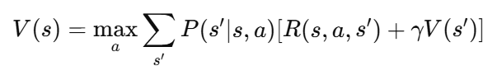
- Repeat until values converge.
- Extract the optimal policy by choosing the action with the highest value for each state.

Part C – Simple Scenario Example
Let’s consider a 3-state environment:
  - S1 (Start)
  - S2 (Intermediate)
  - S3 (Goal): [0, 1, 1, 1, 0, 0, 1, 1, 0, 1]
  - Discount factor γ = 0.9
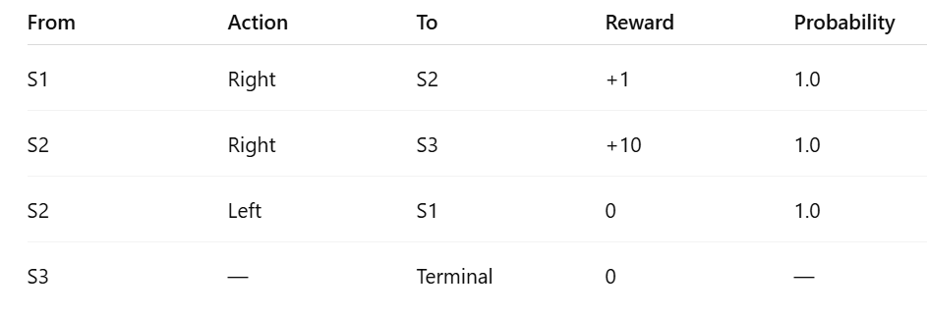
Part D – Visualization
- Display state values as a bar chart.
- Annotate each state with its optimal action.

SCREENSHOT OF CODE
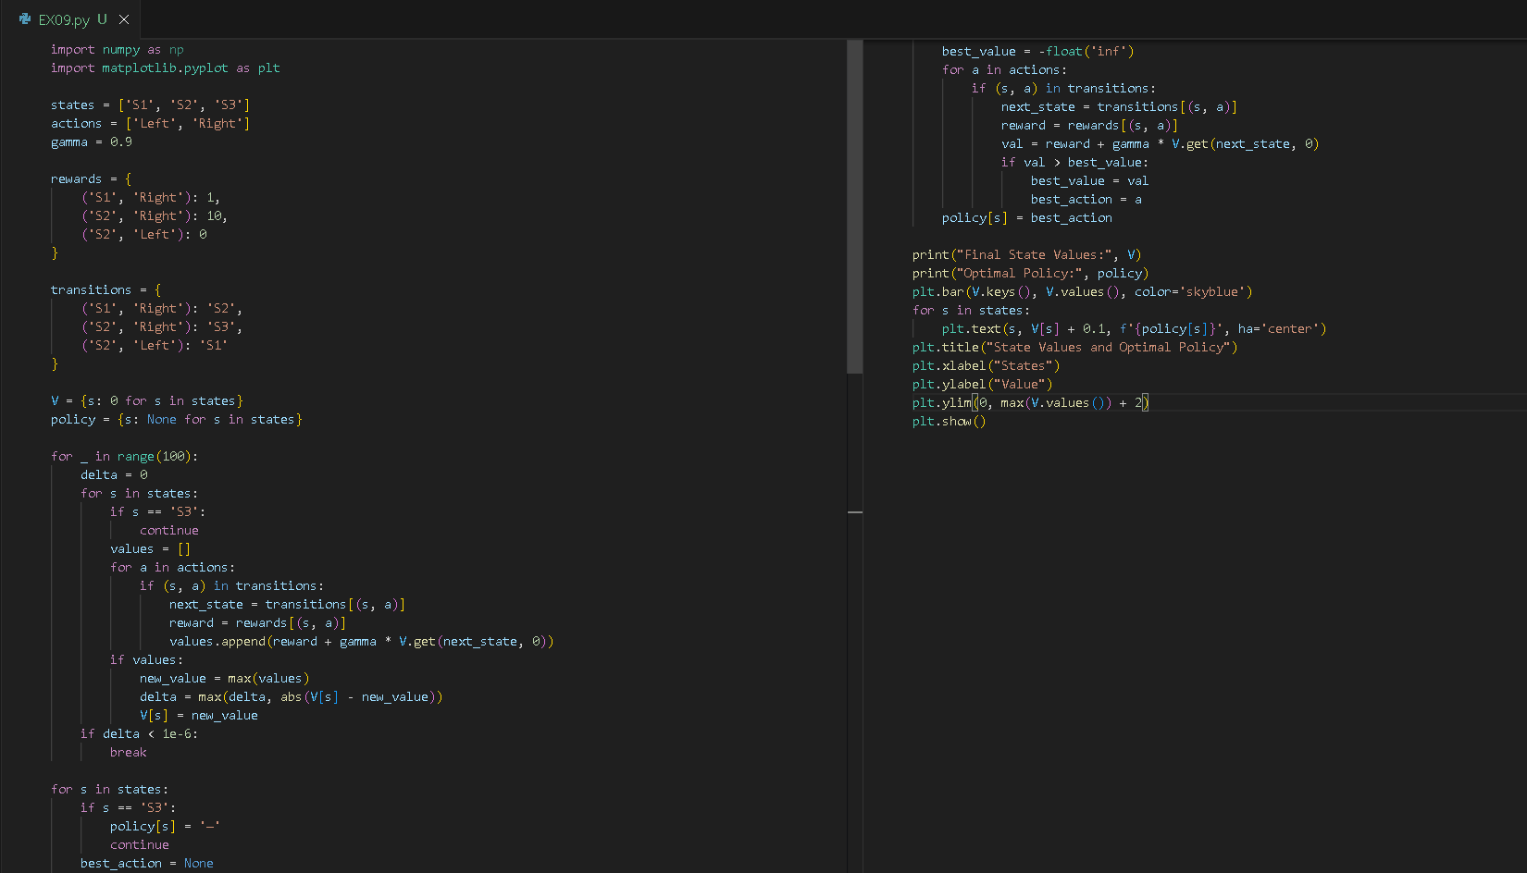

SCREENSHOT OF OUTPUT
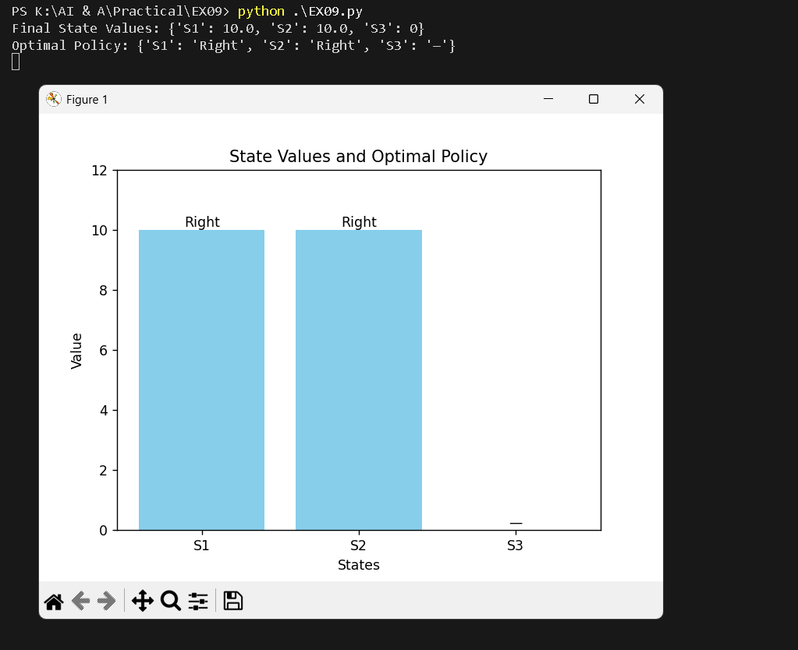

POST-LAB QUESTIONS (Write the answers in your AI and Automation Notebook)
- What is the role of the discount factor (γ) in MDPs?
The discount factor (γ) determines how much future rewards influence current decisions; higher γ values prioritize long-term rewards over immediate ones.

- How does Value Iteration differ from Policy Iteration?
Value Iteration repeatedly updates state values until convergence, while Policy Iteration alternates between evaluating and improving policies to find the optimal strategy.

- If you increase γ from 0.9 to 0.99, what happens to the optimal policy?
Increasing γ from 0.9 to 0.99 makes the agent value future rewards more, leading to more farsighted and sustainable decision-making.

- Explain why MDPs are useful for AI-based decision-making in uncertain environments.
MDPs enable AI to make optimal decisions under uncertainty by modeling probabilistic outcomes and balancing short-term and long-term rewards effectively.

- Suggest a real-world example of using MDPs for energy-efficient AI systems.
MDPs can optimize energy-efficient data center management, adjusting cooling and computation dynamically to minimize power consumption while maintaining performance.

RESULT:
The Markov Decision Process (MDP) was successfully implemented in Python. The Value Iteration algorithm computed optimal state values and derived the best policy for each state. The model demonstrated how AI agents can make optimal decisions in dynamic environments.

ASSESSMENT (Write in your lab notebook)
Description | Max Marks | Marks Awarded
Pre Lab Exercise | 5
In Lab Exercise | 10
Post Lab Exercise | 5
Viva | 10
Total | 30
Faculty Signature

